*Florida International University*

*School of Computing and Information Sciences*

Software Engineering Focus

Feature Document

User Story #**880**

**Team Member:**

Daylin Gonzalez Miguel

**Product Owner(s)**:

Eddy Garcia

**Mentor(s)**:

NA

**Instructor**: Masoud Sadjadi

**User Story** Create a registration page so the users can register in our web page

* As a developer I need to create a registration page, users can register in our web page
* As a developer, I need to connect to the server to see what is inside so i can develop the registration page
* As a developer, I need to connect to the current database to analyse the current tables design
* As a developer I need to create a user so the database can be accessed remotely
* As a developer, I have to install Asp.Net Core local and in server to be able to publish web page into the server because there are compatibility issues

Acceptance Criteria

* Registration page is created

**Use Case** #**880 – Create registration page**

|  |  |
| --- | --- |
| **Name** | **Create Account** |
| **Brief Description** | **The Create Account use case allows the User to create a login and become a Registered User.** |
| **Actor(s)** | **Guest** |
| **Flow of Events** | |
| **Basic Flow** | |
| **This use case starts when the User accesses the system feature that enables him/her to create an account by entering information that is maintained in the User’s account.**  **1. The User enters the required *User Account* information values and requests that the system saves the entered values.**  **2. The system validates the entered *User Account* information.**  ***3.* The values for the *User Account* information are stored in the User’s account. The system notifies the User that the account has been created.**  ***4.* The use case ends** | |
| **Alternate Flows** | |
| **Title** | **Description** |
| **User Enters Invalid User Account Information** | **If during Create Account, the system determines that the User entered invalid *User Account* information, the following occurs:**  **1. The system describes which entered data was invalid.**  **2. The system prompts the User to re-enter the invalid information.**  **3. The User re-enters the information and the system re-validates it.**  **4. If valid information is entered, the User Account Information is stored.**  **5. If invalid information is entered, the Entered Information is Invalid alternative flow is executed again. This continues until the User enters valid information.**  **Invalid *User Account* information:**  **- Missing information items**  **- Username already exists in the system**  **- *User Account* information entered does not comply to its definition in the glossary**  **- Not well formed e-mail address** |
| **Pre-Conditions** | |
| **Title** | **Description** |
| **None** |  |
| **Post-Conditions** | |
| **Title** | **Description** |
| **Success** | **The User entered data is stored in the user account.** |
| **The user account was not created** | **The User entered invalid data. No account will be created.** |
| **Extension Points** | |
| **None** | |

**Use Case Diagram**

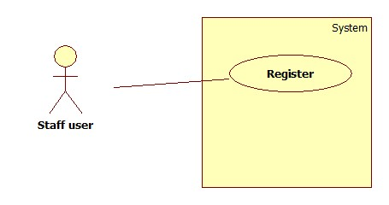

**Sequence Diagram**

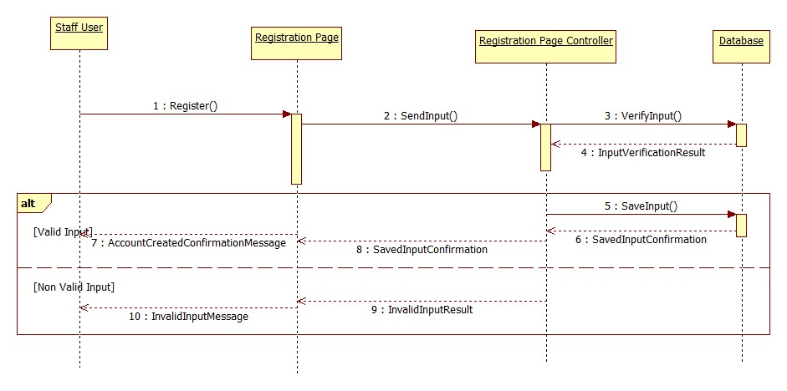

**Class Diagram**

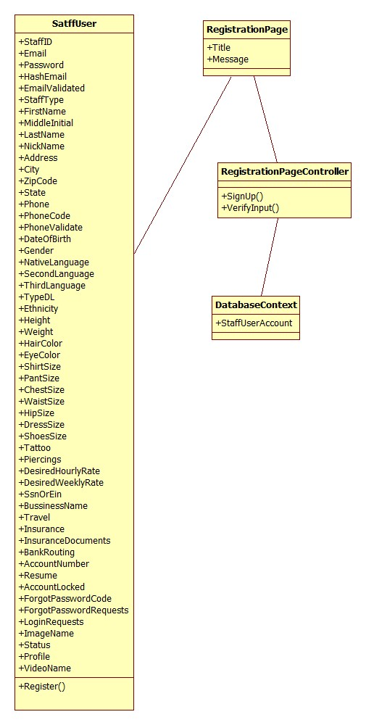

**Unit Test**

|  |
| --- |
| **Test ID: UT-001** |
| **Purpose: Test that the SignUp() in the SignUpController class returns the registration page view** |
| **Preconditions: Internet browser is open and application is running** |
| **Input: //localhost:60097/Home/SignUp** |
| **Expected Output: The registration page shows up with all the required fields** |

**Integration Test**

|  |
| --- |
| **Test ID: IT-001** |
| **Purpose: Verify whether the web page will have all the required fields to create an account** |
| **Preconditions: Internet browser is open and application is running** |
| **Input: http://localhost:60097/Home/SignUp** |
| **Expected Output: The registration page shows up with all the required fields** |

**Connection to the server**

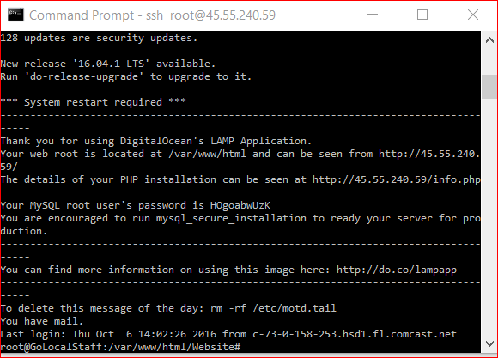

**Connection to the database**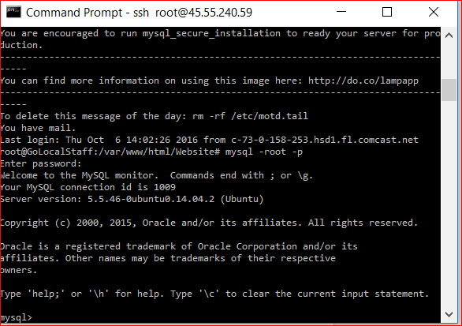

**MySql remote user created**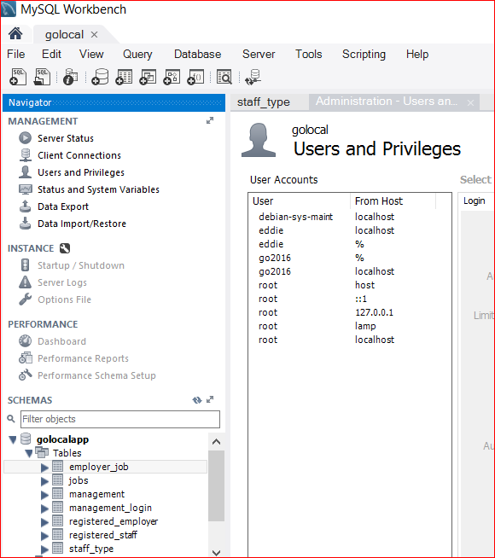

UserName: go2016

Host: % (any)

**Visual User Guide**